**Moew machine HTB challenge**

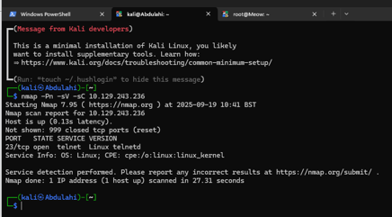

In this image we can see that I am using a network enumeration tool Nmap to find vulnerabilities in the machine which he can then use to exploit the machine. In this scenario the machine was using a linux operating system and had port 23 open which had a telnet service running. The attacker now knows that he can telnet into the machine and dig for information about the machine.

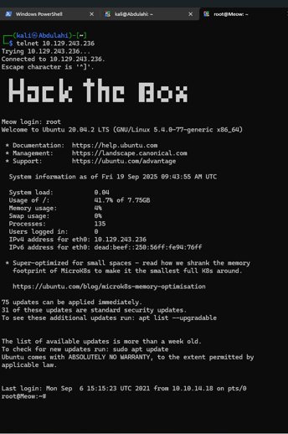

We can see now that I have gained access to the machine. I can use tools such as ls to list the directories running on the machine. I can also use another tool called nano to see into files.

